1. Before you start, go to Mechanical 1 layer, and draw a border around the pcb using lines. This will make it so you can see the board outline later on.

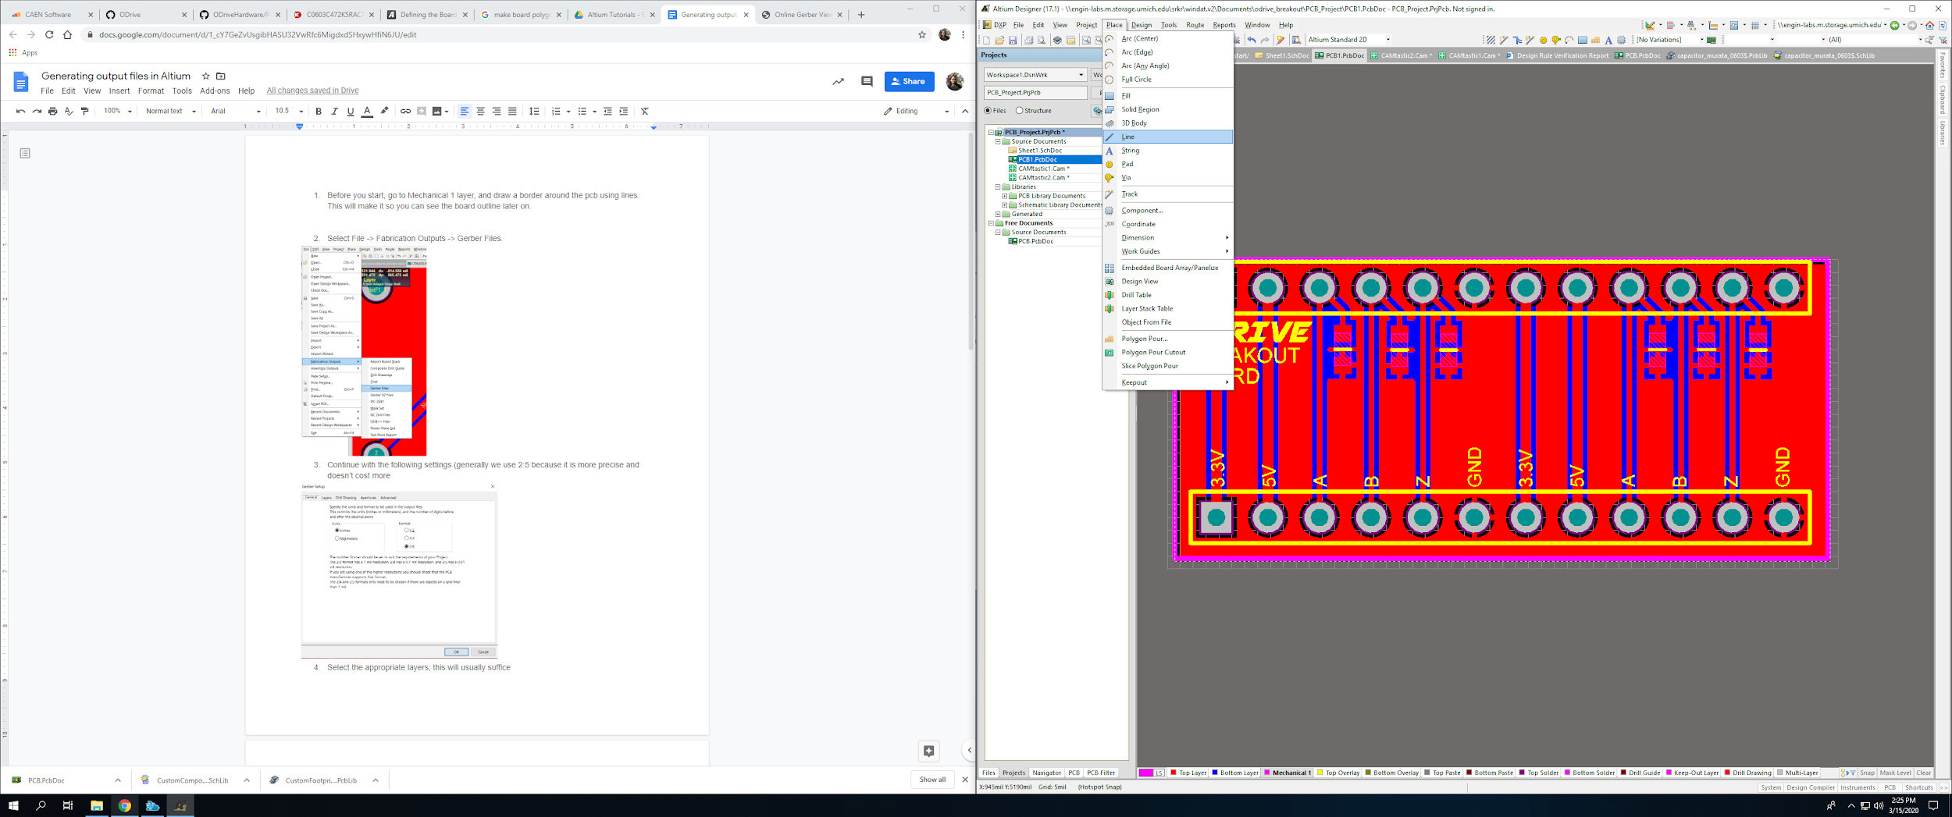

1. Select File -> Fabrication Outputs -> Gerber Files.

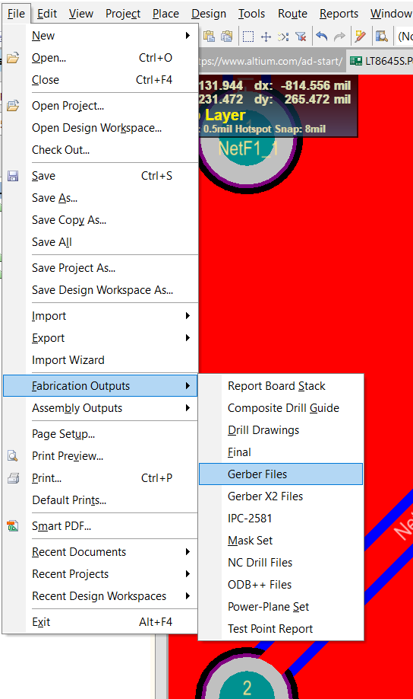

1. Continue with the following settings (generally we use 2:5 because it is more precise and doesn’t cost more

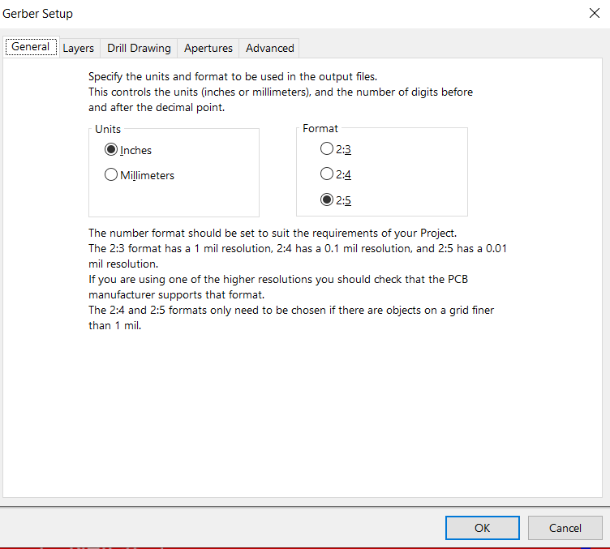

1. Select the appropriate layers; this will usually suffice

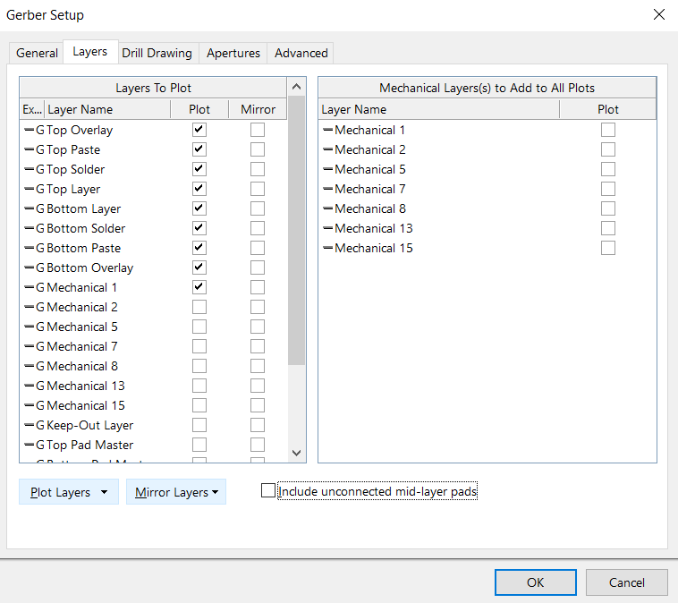

1. Check/ uncheck all the layers that come up in the camtastic file to make sure the boards looks the way you designed it
2. You can save the Camtastic (doesn’t matter) but the gerber files will be in a folder called Project Outputs in your main project directory

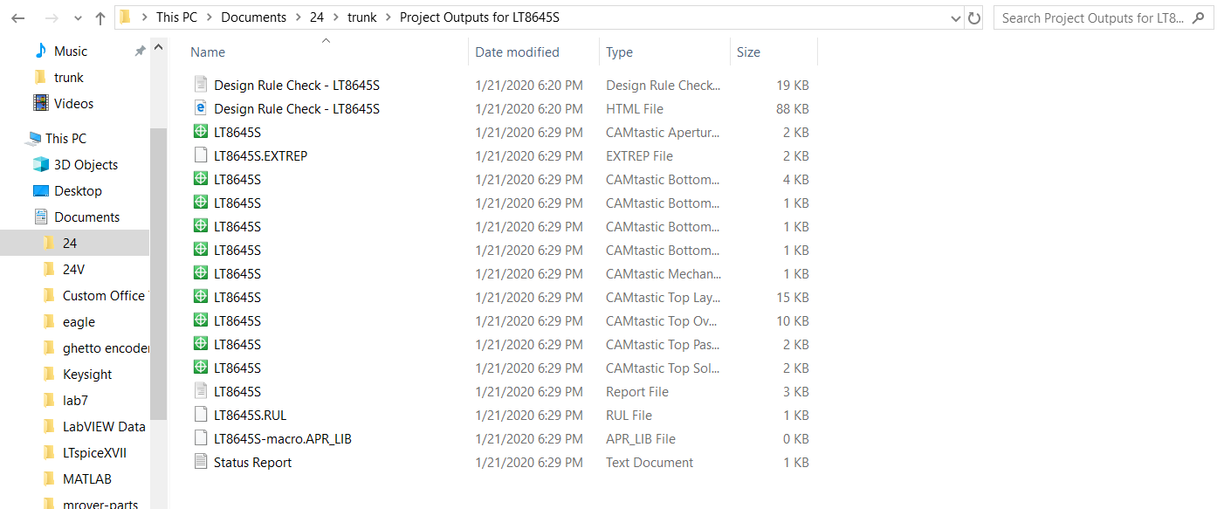

1. To generate the holes in the board properly, we also need NC Drill output files. In Fabrication Outputs, select NC Drill Files. Select OK on the dialog and there should be a .drl file in the outputs folder
2. Zip the folder and go to a website like [this one](http://www.gerber-viewer.com/) to visualize your output before sending it to the manufacturer